BYOD for Registered Training Organisations

Template for Developing a Technical Brief

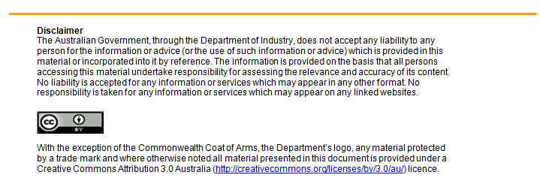

flexiblelearning.net.au
RTO Name:
RTO Address:
Contact Name:
Position:
Contact Number:
Contact Email:

1. Project details
Project commencement date:

Project completion date:

What is your approximate budget?

What are the primary objectives?

Are there any regulatory considerations?

What is inside the scope of the project?

What is not in scope?

2. Resources audit:

What is your current internet connection?
(eg: ADSL2, NBN Fibre, NBN Wireless, 3G/4G Internet, Satellite, Unsure, No internet connection)

Internet Speedtest results (if applicable)
Run an online speed test (eg www.speedtest.net) and enter the results below:

Download:
Upload:
Ping:

Who is your Internet Service Provider (ISP)?

Do you currently have any form of wireless infrastructure?

Do you currently have any form of cabled infrastructure?

Do you currently offer any form of BYOD to staff/students/guests?

Do you have multiple physical locations (sites)?

How many staff do you have?

How many staff are likely to make use of a BYOD solution?

How many students do you have?

How many students are likely to make use of a BYOD solution?

Do you wish to allow guest access to your BYOD solution?

Are any of the below are likely to increase in number over the next 3 years?

- staff
- students
- guests
- number of sites

What are planned end uses of BYOD in your RTO?
(select as many as apply)

- Video conferencing
- General Internet access
- Video streaming
- Email (Web based such as gmail, other)
- Email (using an installed application such as Outlook)
- Access to LMS (Internally hosted LMS)
- Access to LMS (Externally hosted LMS/Cloud hosted LMS)
- File sharing
- Audio streaming
- Other - please specify
Do you wish to restrict Internet access to certain sites or categories?

Do you wish to limit internet access speed (bandwidth)?

Do you wish to limit internet access duration (i.e. specific time of day, certain number of hours per day)?

Do you wish to limit internet access downloads/quota?

Do you wish to log user access to internet resources (note that this may be a requirement)?

Do you wish to separate staff, student and guest networks for security purposes?

Do you require external access to your network for BYOD devices?

Do you wish to be able to push applications or settings to the BYO devices?

Which platforms do you wish to support?
(Select as many as apply)

- Android
- Apple iOS (iPhones, iPads)
- Microsoft Windows
- Microsoft Windows Mobile
- Mac OS
- Other

Which internet connectivity types does your BYOD solution need to support?

- wireless
- wired (ethernet)

Is there an optimal time period in which this work should commence? (eg. Semester breaks, when learners are on placement, particular times of day).

Are there any particular concerns that have not been mentioned that you wish to address?

3. Measuring and reporting
Specific measures of success:

Review dates, milestones and deliverable:
(Add rows as necessary)
Date | Milestone/ Deliverable | Responsible person

